**Application for Observing Time on the MSRO**

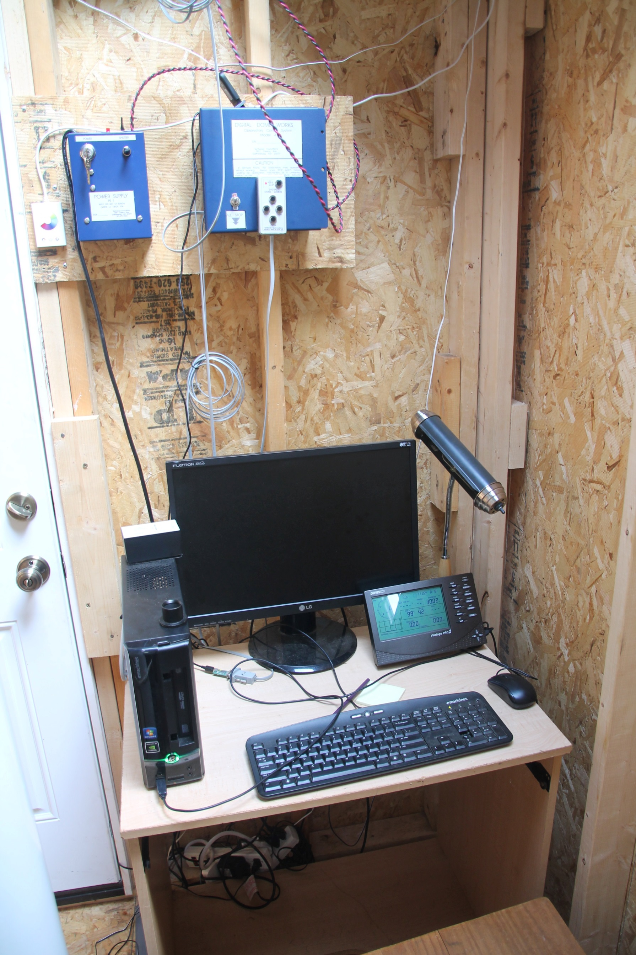

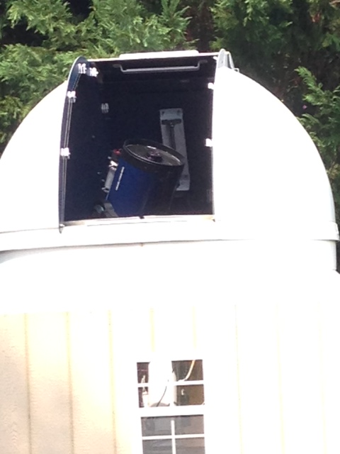

There is no charge to use this observatory. However, if you would like to make a small donation, please contact the Director via email for details.

Name:_________________________________   
  
Address:________________________________ Phone:__________________

________________________________ Email:___________________

________________________________

MSRO Observer Level Requested During Observation

___Guest Observer ____ I want to be online during observation.

___Guest Observer ____ I do not want to be online during observation. P  
 Please contact me when observation has been obtained.

___Observer in Training  
___Full Observer

Please describe your observation request as thoroughly as possible. Give details such as when observation should be made (or whether it is not time sensitive such as “I just want a picture of this galaxy,” etc.), what object you would like to observe, the goals of your observation, approximate amount of telescope time needed, and if any special filters or techniques need to be used.

Object s _____________,_____________,_____________,_____________,_____________

__________________________________________________________________________________________________________________________________________________________________________________________________________________________________________________________________________________________________________________________________________________________________________________________________________________________________________________________________________________________________________________________________________________________________  
____________________________________________________________________________________________________________________________________________________________________________________________________________________________________________________________________________________________________________________________________________________________________________________________________________________________________________________________________________________________________________________________________________________________________________________________________________________________________________________________________________________________________________________________________________________________________________________________________________________________________________________________________________________________________________________________________________________________________________________________________________________________________________________________________________________________________________________________________

MSRO Staff/Commission Comments:

Approved______ Approved pending following recommendations______ Denied________

____________________________________________________________________________________________________________________________________________________________

___________________________________________________________________

Please contact MSRO Director Myron Wasiuta with questions about scheduling your observation request at [myrnteryx4@aol.com](mailto:myrnteryx4@aol.com)

For technical help with your observations or analysis of your data, please email MSRO staff astronomer Lauren Lennon at [lmn12@case.edu](mailto:lmn12@case.edu)